**LITERATURE SURVEY**

SMART FASHION RECOMMENDER APPLICATION

*A literature review surveys books, scholarly articles, and any other sources relevant to a particular issue, area of research, or theory, and by so doing, provides a description, summary, and critical evaluation of these works in relation to the research problem being investigated.

**Problem Identification:**

*This application is intended to provide information about fashion industries have witnessed an enormous amount of growth in fast fashion. On e-commerce platforms, where numerous choices are available, an efficient recommendation system is required to sort, order, and efficiently convey relevant product content or information to users.

* Smart fashion recommendation application have attracted a huge amount of attention from fast fashion retailers as they provide a personalized shopping experience to consumers. With the technological advancements, this branch of artificial intelligence exhibits a tremendous amount of potential in image processing, parsing, classification, and segmentation.

**Problem Solution:**

*The project aims at building an application that provides information about Online e-stores like Amazon, eBay, etc. customize fashion recommendation systems to satisfy the daily requirements of their customers work like highly personalized online shopping recommendations. A recommendation system is a system that is programmed to predict future preferable items from a large set of collections.

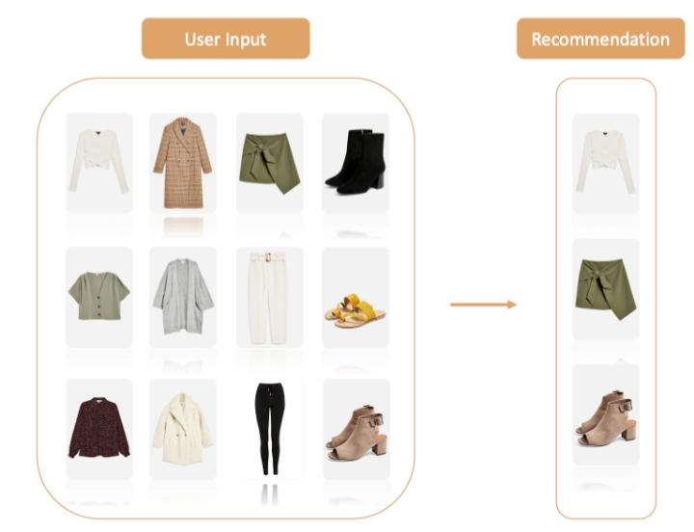

**REFERENCES:**

<https://www.fennel.ai/?gclid=Cj0KCQjwvZCZBhCiARIsAPXbajvVMlU_MttErBsiYY1OtUUwbzrvwf8VsTkv_eWZIm4XXJrf8R3xxBUaAjofEALw_wcB>

**CONCLUSION:**

* Finally , in the analysis of this systematic literature review, recommendations to address these challenges, future directions, and Considerations in the use of Smart Fashion Recommender Application review paper will guide future aspirants to conduct further in-depth and innovative empirical research on fashion recommendation systems.